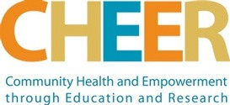

Long Branch Collective Action for Youth
I S S U E # 4 | D E C 2 0 2 2

Announcements
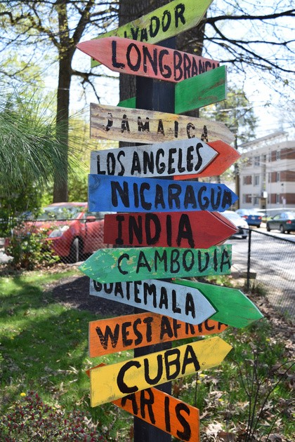
LBCAY Stakeholder meeting in-person Special Guest: WorkSource Montgomery
When: Wednesday, January 18, from 3:30-5:30 pm Where: Long Branch Community Recreation Center 8700 Piney Branch Road Silver Spring, MD, 2090
If you have questions, send an email to Naidia Douglas, LBCAY Communications, at naidia@communitycheer.org
LBCAY Steering Committee News
The LBCAY Steering Committee would like to announce a transition in leadership roles for its 4th year of collective impact work in the Long Branch Community.
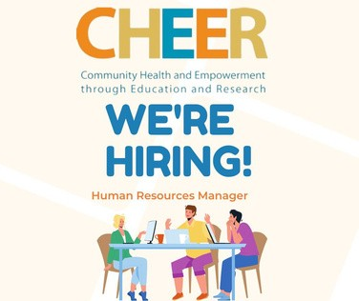
CHEER has assumed the grantee role and primary lead for the LBCAY initiative for FY23, with funding from Montgomery County. YMCA Youth and Family Services will continue as an important member of the LBCAY collaborative, and we thank them for their invaluable leadership over the past three years.
LBCAY looks forward to exciting new opportunities for community partnerships, youth leadership, and engagement with community members in the coming year.
For links to the Long Branch Collective Action for Youth LBCAY Unified Plan and supporting documents:

Click here below for more information!
https://www.communitycheer.org/lbcay

Partner Highlight: LAYC (Latin American Youth Center)

Empowering a diverse youth population to achieve a successful transition to adulthood through multi-cultural, comprehensive, and innovative programs that address youths’ social, academic, and career needs is LAYC's mission.
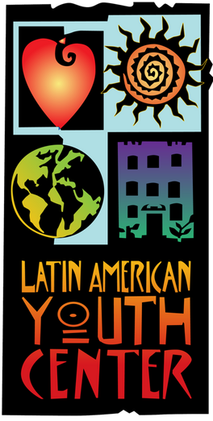
Since its founding in the late 1960s, LAYC has grown from a small grassroots recreation center into a nationally recognized agency serving all low- income youth. Each year LAYC serves over 4,000 youth and families through youth centers, school-based sites, and public charter schools in the District of Columbia and Prince George’s and Montgomery Counties.
LAYC offers over 50 programs and services for our region’s youth to pursue success in the following areas: academic, arts, recreation, and job readiness, including opportunities for youth in the Long Branch community.
Briana Hodge is the outreach/intake specialist at Moco Reconnect with LAYC and has provided the information below:
The Moco Reconnect Drop-in/ Re-engagement Center, located at 11319 Elkins St. in Silver Spring, is the first youth-based drop-in center in Montgomery County. MoCo ReConnect offers a unique approach as the only dedicated youth space in the county, specifically centering the needs of youth ages 16-24, particularly those impacted by housing insecurity and seeking alternative opportunities to traditional education pathways. The center offers Case Management, GED, Mentorships/counseling, and Job Readiness which includes recurring cohorts and workshops. In addition, our youth has daily access to clean showers, hot meals, laundry facilities, and a meditation lounge.
Recent workshops we have offered include: “Who Am I,” Career Development & Entrepreneurship, and Story Tapestries. Upcoming events include a Youth Holiday Party on December 22nd from 3-6 PM at Moco Reconnect in Silver Spring.
For more information about LAYC, please visit https://www.layc-dc.org/. For additional information about Moco Reconnect, visit https://mocoreconnect.org/.

New Team Member Alert
We also welcome our newest LBCAY Steering Committee member, Cynthia Rubenstein, to the team. Cynthia has been a Long Branch and East Silver Spring resident since 1983. She is also the recently retired Founding Executive Director of Passion for Learning, Inc. (P4L), a nonprofit that since 2003 has provided STEM enrichment and early college awareness-readiness programs for underserved MCPS students. Annually, P4L serves dozens of Long Branch students attending Eastern and Silver Spring Int’l Middle Schools as well as Montgomery Blair and Northwood High Schools.

